

**2021 AEC IRC MEETING – INFO VIGO TOURISM OFFICE**

USEFUL LINKS:

[VIGO STUARY](http://www.turismodevigo.org/en/vigo-estuary)

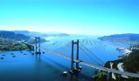

[NATURE](https://www.youtube.com/embed/Y2-E3sBOPBU?autoplay=1&showinfo=0) - [CIES ISLANDS](http://www.turismodevigo.org/en/trip-cies) – [NATIONAL PARK](http://www.turismodevigo.org/en/trip-cies)

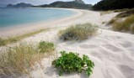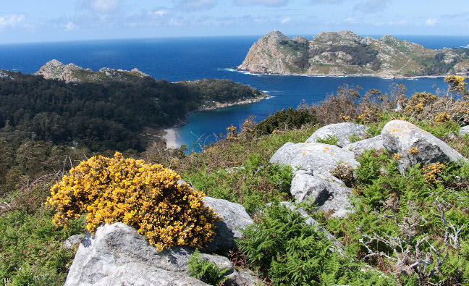

[FLAVOURS](http://www.turismodevigo.org/en/sea-flavours): [GRASTRONOMIC DICTIONARY](http://www.turismodevigo.org/en/mini-gastronomic-dictionary)

|  |  |  |  |  |
| --- | --- | --- | --- | --- |
|  |  |  |  |  |
| Zamburiñas  Scallops | Pulpo (Gal. *Polbo*)  Octopus | Percebes  Barnacles | Nécoras  Spider Crabs |  |
|  |  |  |  |  |
| Padrón Pepper | Empanada - Pie | Xouba-Sardines | Mejillones-Moussels |  |

[CULTURE](http://www.turismodevigo.org/en/sea-culture)

[Old Town](http://www.turismodevigo.org/en/vigos-old-town)

