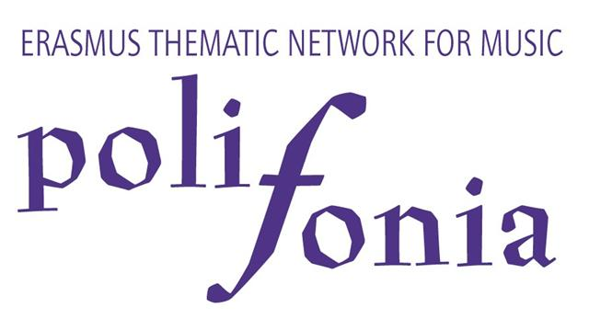

Questionnaire on
The admission to higher music education

Pre-college Working Group
C QUESTIONNAIRE ABOUT TEACHER
This questionnaire has been designed by the ‘pre-college working group’ of the Polifonia project. This working group is studying issues in relation to the preparation of music students for and their admission to professional music training in higher education (Musikhochschule, Conservatoire Supérieur, University). An important aim of the group is to gain insight into the admission procedures to higher music education. This questionnaire focuses on this item.

Name Institution:
Name contact:
E-Mail:
Phone: | Fax:

- In the admission exam to studies at a 1st cycle (Bachelor) level what of the following do you test?

1.1 Theoretical knowledge
Analysis
Music history
Technical knowledge/skills (e.g. music software)
Aural skills
Other, please specify:

1.2 Practical skills
Artistic expression
Knowledge of different music styles
Ensemble playing
Prima vista playing
Improvisation skills
Other, please specify:

- Do you interview candidates? YES NO

- Do you give candidates a written assignment? YES NO

- Do you ask for references? YES NO

- How much importance do the above mentioned categories have for the admittance of a student? Please mark importance where applicable to your institution. Not important Very important
Analysis 1 2 3 4 5 6
Music history 1 2 3 4 5 6
Technical knowledge/skills 1 2 3 4 5 6
Aural skills 1 2 3 4 5 6
Other 1 2 3 4 5 6
Artistic expression 1 2 3 4 5 6
Knowledge of different music styles 1 2 3 4 5 6
Not important Very important
Ensemble playing 1 2 3 4 5 6
Prima vista playing 1 2 3 4 5 6
Improvisation skills 1 2 3 4 5 6
Other 1 2 3 4 5 6
Interview 1 2 3 4 5 6
Written assignment 1 2 3 4 5 6
References 1 2 3 4 5 6

- (a) Do you make any exceptions to the admission process (e.g. asking only for single parts of the exam, CD replacing live audition etc.)? YES NO

(b) If YES, please explain.

- (a) Are there any language requirements at admission? YES NO

(b) If YES, please explain.

- Do you offer potential students a possibility to have an informal consultation with conservatoire teaching staff before the admission exam (e.g. information day)? YES NO

- (a) Are there any other legal or practical requirements to be fulfilled before a student can be admitted (e.g. school leaving examination, age limit)?
YES NO
If YES, please name.

- How is your admission panel composed?
Only internal examiners
Only external examiners
Internal and external examiners

- (a) Who assigns admitted students to a teacher?
Administration
Admission panel
Other, please name
(b) Are students’ requests for a specific teacher considered? YES NO

- From the total number of candidates that you consider admissible to your institution, what factors other than the student’s competence will determine which of these will receive the offer of a place?
Financial resources
Balance between disciplines/instruments
Teacher availability
Other, please name

- Do any external circumstances force you to admit students that do not fulfil your admission standards? YES NO
If YES, please name.

- Which type of previous education have students from your country received before they enter the 1st cycle (Bachelor) at your institution? Please note: It is not necessary to have exact numbers about this issue; we are just looking for trends; your personal experience should be sufficient to answer the following question.

Please use numbers from 1-8 to mark frequency: 8 most students in my institution origin from this type of education – 1 no students in my institution origin from this type of education; 0 not applicable.

Junior department/Preparatory Class/Foundation year  Course within the higher education institution preparing students for training in higher music education. | 0 1 2 3 4 5 6 7 8
General music school  Independent institution for music education outside of the compulsory education system and higher education, offering education in music to students of all ages and all stages. | 0 1 2 3 4 5 6 7 8
Specialised music school  Independent institution for music education outside of the compulsory education system and higher education, offering special curricula preparing students for professional music training in higher music education. | 0 1 2 3 4 5 6 7 8
Secondary level educational institution specialised in music A  School on secondary level offering general education with a specialisation in music education. | 0 1 2 3 4 5 6 7 8
Secondary level educational institution specialised in music B  School on secondary level offering music education on an advanced level including general education. | 0 1 2 3 4 5 6 7 8
Secondary level educational institution specialised in music C  School on secondary level offering music education on an advanced level without general education. | 0 1 2 3 4 5 6 7 8
Private lessons | 0 1 2 3 4 5 6 7 8
Other - Which? | 0 1 2 3 4 5 6 7 8

- (a) Does your institution charge enrolment fees from students?
YES NO

(b) If YES, How much are they? €

- (a) Do you admit foreign students to you institution? YES NO

- If YES, is there any restriction for that?

Additional Comments

Thank you for your cooperation!
Please send the completed questionnaire by e-mail, mail or fax to: Ester Tomasi, Polifonia research/project assistant, Association Européenne des Conservatoires, Académies de Musique et Musikhochschulen (AEC), PO Box 805, NL-3500 AV Utrecht, The Netherlands
T: +31/302361242, F: +31/302361290, E: estertomasi@aecinfo.org

Fur further information on the Thematic Network for Music “Polifonia”, please have a look at our webpage www.aecinfo.org/polifonia.htm.

